**SP/RM[1,1] – Enrichment Key**

**Type in your score here 🡪 ____ out of 29 points possible**

1. (5 points) Ponder/Reflect Exercise – Reflect on what you have learned from this portion of the class. Examples of what you can do are: a brief outline of material covered, insights you gained from class or personal study, or items you feel that you need to follow up or work on. (3-5 sentences)

**Any thoughtful answer is sufficient.**

2. We are interested in comparing 4 different methods for preparing for the ACT exam:

* Method A: Control-just take the exam
* Method B: Take one practice exam
* Method C: Take a prep course online
* Method D: Be hypnotized the day before

You are interested in assessing the power of the F test (in ANOVA) for detecting differences in preparation method means when the significance level is α = 0.05.

(a) (6 points) Suppose that ACT scores have a standard deviation of 4.7, and suppose we would like to evaluate the possibility that the group means are , , , and . In R, make a plot that shows the power of the F test when n = 2, 3,…, 20.

Note: after using the power.anova.test command in R for every sample size, do the following:

1. **Use the code in the Running code to get the following graph:**

(Print and include this plot with your homework.)



(b) (2 points) What is the smallest value for the group size (n) that gives 80% power?

**Sample Size = 13**

(c) (4 points) What happens to your power curve if your hypothesized means are , , , and ? Explain this at a level of an FDMAT 22x student.

**For every sample size, compared to the previous problem, the level of power is higher. This is due to the 27 having a greater difference (compared to the other groups), than the previous problem. As difference comparison increases, the level of our power also increase, which also means our probability of a type II error decreases.**



3. The figure below illustrates issues related to the power of hypothesis tests in ANOVA. The top picture refers to the null hypothesis and the bottom picture refers to the alternative hypothesis.

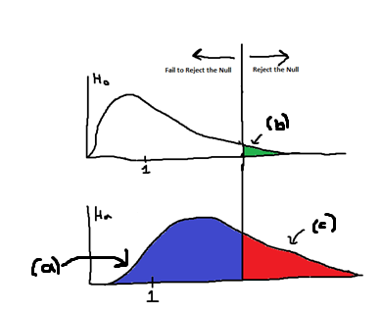

(a) (1 pt) What is the name of the distribution labeled (a)? **Non-central F distribution**

(b) (1 pt) What is the name for the area marked as (b)? **α (Prob of Type I Error)**

(c) (1 pt) What is the name for the area marked as (c)? **1-β (Power)**

4. In this problem, you will use SAS or R to do a complete analysis of variance on the head injury severity scores associated with 7 types of cars. The data are found in the file headinjury.csv (note that it is comma-delimited) or SAS filename *headinjury*

(e) (9 points) Do the analysis, assuming that instead of looking at all the pairwise comparisons, you only want to consider 3 different contrasts:

(i) mean of the pickups&vans&minivans minus the mean of the other 4 car types,

(ii) mean of the heavy&medium cars minus the mean of the light&compact cars, and

(iii) mean of light cars minus mean of compact cars.

Do the three steps so that you can get the correct contrasts you need to put into either SPSS or R.

Use your chosen approach and interpret the 3 contrasts described- which contrasts are

statistically significant? NOTE: When specifying contrasts, if you need to enter , use

0.333 not 0.33.

**i.**

**Step 1**

**Step 2**

**Step 3 Contrast to input in R (but put in decimal form in R)**

**ii.**

**Step 1**

**Step 2**

**Step 3 Contrast to input in R (but put in decimal form in R)**

**ii.**

**Step 1**

**Step 2**

**Step 3 Contrast to input in R (but put in decimal form in R)**

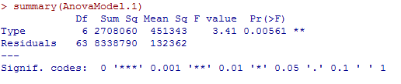



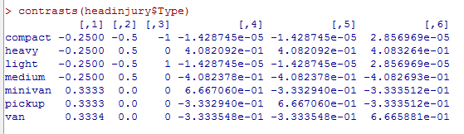

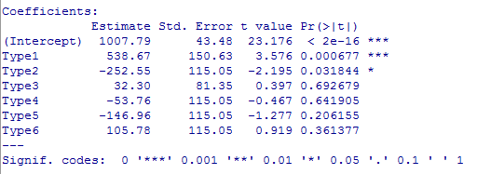

**The first two contrasts are significant contrasts but the third is not.**